**URL: http://www.clalit.org.il/haemek/defaulteng.asp**

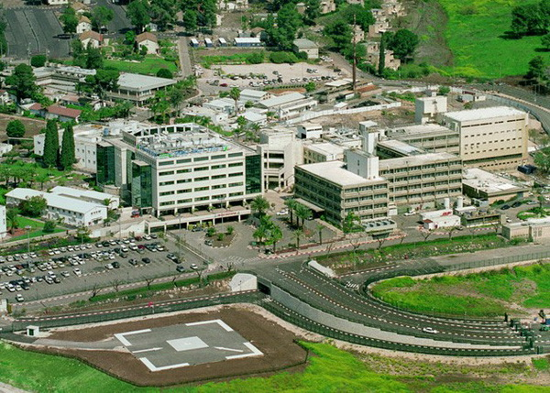

Every hospital has been affected and Emek’s ability to maintain its level of services is being eroded. The immense challenge facing us today is to continue growing while increasing our level of efficiency without negatively affecting our high medical standards or our excellent patient relationships. Plans are now drawn for a new Surgical Complex that will eventually include 12 ultra-modern Operating Rooms, a new Sterile Supply Unit and various surgical departments. Our primary focus, in order to answer immediate needs, is to first build and equip 4 — 6 new Operating Rooms. Funding will determine the rate of further progress. We salute all of our friends who have joined us in our quest .to provide better healthcare for our peopleEmek Medical Center is affiliated with the Rappaport Faculty of Medicine of the Technion in Haifa. The Center takes an active role in educating Israel's future generation of physicians and makes available many of its wards and special care units for the advancement of academia and research. Many of today's practicing doctors in Northern Israel are graduates of Emek.

**Services:**

**Emek Medical Center’s 25 Departments:**

|  |  |  |
| --- | --- | --- |
|  | · Internal Medicine (4)  · Pediatric (2)  · Surgery (3)  · Orthopedic  · Urology  · ENT  · Cardiac ICU  · General ICU  · Pediatric ICU  · Neonatal ICU  · Psychiatry  · Dermatology  · Ophthalmology  · Plastic Surgery  · Obstetrics & Gynecology  · Imaging Services  · Emergency Room  · Anesthesia |  |
|  |

**Emek’s Ambulatory Services:**

|  |  |  |
| --- | --- | --- |
|  | · 60 clinics  · Dialysis  · Oncology – adult and pediatric  · Hematology - adult and pediatric  · Pulmonary Service  · Rheumatology Service  · Pain Service  · Genetic Service  · Gastroenterology |  |
|  |

**Distinctive Services**

|  |  |
| --- | --- |
|  | **Emergency medicine:**  • Voted #1 in patient satisfaction  **National referral center for:**  · Surgery – specialized treatments  · ECMO  · BMV  · Retinal Surgery  **Regional referral center for:**  · PUVA Institute – Dermatology  · Fetal Medicine  · IVF  · Genetics |
|

**Contact us:**

Via regular mail:   
Emek Medical Center   
Afula 18101, Israel

Via Email: [rich_l@clalit.org.il](mailto:rich_l@clalit.org.il)   
Via fax : 972-4-652 2642